**PRACTICE QUESTIONS**

**Q1:Given : kid, teen, adult, old. kid <12 , teen > kid to 18 , adult 18 to 60 , old above 60**

CODE:

age=21

if(age<12):

print("you are a kid")

elif(age>12 and age<=18):

print("you are a teenager")

elif(age>18 and age<=60):

print("you are an adult")

else:

print("you are old")

**Q2: create list, print specified index item, change item and append list by all ways, remove item using del,clear,remove all**

CODE:

list=[1,2,"anu","priya",True]

print(list)

print(list[2])

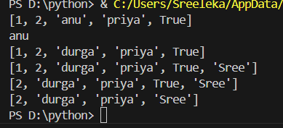list[2]="durga"

print(list)

list.append("Sree")

print(list)

list.remove(1)

print(list)

del list[3]

print(list)

**Q3:Write a program with Escape Characters**

CODE:

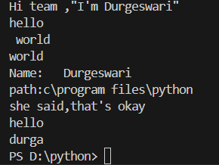print("Hi team ,\"I'm Durgeswari\"")

print("hello\n world")

print("hello\rworld")

print("Name:\tDurgeswari")

print("path:c\\program files\\python")

print("she said,that\'s okay")

print("helloo\b ")

print("\144\165\162\147\141")

**Q4: create tuple, access tuple, loop, range, slice, update items**

CODE:

tup = (10, 20, 30)

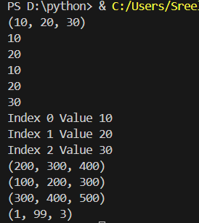print(tup)

print(tup[0])

print(tup[1])

for a in tup:

    print(a)

for i in range(len(tup)):

    print("Index", i, "Value", tup[i])

tup2 = (100, 200, 300, 400, 500)

print(tup2[1:4])

print(tup2[:3])

print(tup2[-3:])

tup3 = (1, 2, 3)

temp = list(tup3)

temp[1] = 99

tup3 = tuple(temp)

print(tup3)

**Q5:STAR PYRAMID**

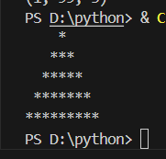

CODE:

rows=5

for i in range(1,rows+1):

   s=rows-i

   strs=2*i-1

   print(" " * s + "*" * strs)

**Q6: ALPHABET PYRAMID**

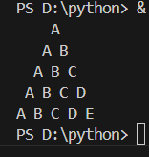CODE:

rows=5

for i in range(1,rows+1):

   s=rows-i

   print(" "*s , end="")

   for j in range(1, i+1):

       print(chr(64+j), end=" ")

   print()

**Q7: NUMBER PYRAMID**

CODE:

rows=5

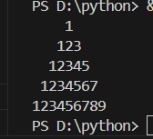for i in range(1,rows+1):

    s=rows-i

    num=2*i-1

    print(" "*s, end="")

    for j in range(1, num+1):

        print(j, end="")

    print()

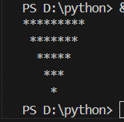**Q8: INVERTED STAR PYRAMID**

CODE:

rows=5

for i in range(rows,0,-1):

    s=rows-i

    str=2*i-1

    print(" "*s +"*"*str)